
YR 10 SCIENCE MODIFIED

SEMESTER 1 EXAM

BIOLOGY

NAME: ____________________________________

CLASS NUMBER: __________________________

Time allowed for this paper
Working time for the paper: 30 minutes

Materials required/recommended for this paper
To be provided by the supervisor
This Question/Answer booklet
Multiple-choice answer sheet

To be provided by the candidate:
Standard items: pens (blue/black preferred), pencils (including coloured), sharpener, correction fluid/tape, eraser, ruler, highlighters

Special items: non-programmable calculators approved for use in this examination

Important note to candidates
No other items may be taken into the examination room. It is your responsibility to ensure that you do not have any unauthorised material. If you have any unauthorised material with you, hand it to the supervisor before reading any further.

 | Marks Awarded | Marks Available
Multiple Choice |  | 10
Short Answer |  | 20
Total |  | 30

Multiple choice:

    - DNA is a type of:
          - Atom
          - Cell
          - Organism
          - Molecule

    - Where is human DNA stored?
          - In the cells of embryos but not adults
          - In the nucleus of each cell
          - In brain cells but not muscle cells
          - In the cytoplasm of each cell

    - Which of the following statements about bases are true?
          - Each base pair is a gene
          - Bases are proteins
          - Human DNA contains four types of bases
          - Any combination of bases can form a base pair

    - Which of the following base pairs is possible?
          - A-C
          - A-T
          - T-G
          - C-T

    - What are the building blocks of proteins?
          - Amino acids
          - Deoxyribonucleic acid
          - Bases
          - Cells

    - What are the two main roles of mitosis in the body?
          - Growth
          - Repair
          - Digestion of food
          - Sexual reproduction

    - The daughter cells produced by mitosis are:
          - Unable to divide again
          - Genetically unique
          - Genetically identical to the parent cell
          - Genetically identical to each other

    - mRNA stands for:
          - Mitochondria RNA
          - Messenger RNA
          - Motor RNA
          - Mexican RNA

    - The ribosome reads the mRNA three bases at a time. Three mRNA bases are known as a:
          - Anti-codon
          - Codon
          - Triplet
          - Coupon

    - The tRNA (transfer RNA) is responsible for:
          - Transporting the ribosome
          - Transporting the mRNA to the ribosome
          - Transporting amino acids to the ribosome
          - Transporting proteins through the cell

Short answer (20 marks)

- Describe three features of DNA structure (shape/what it is made of etc.) (3 marks)

_________________________________________________________________________________

_________________________________________________________________________________

_________________________________________________________________________________

- Complete the complementary DNA strand for the sequence below. (1 mark)

T A C G G A C T T G C A

_________________________________________________________________________________

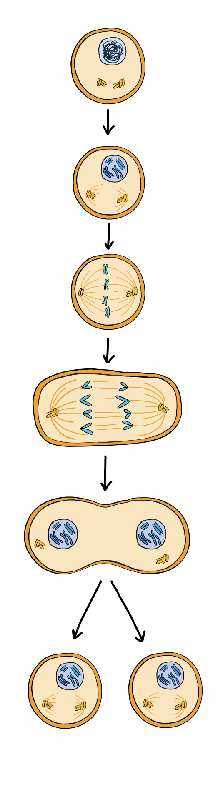




- Label the following stages of the cell cycle and Mitosis. (5 marks)

- Describe the role of the spindle fibres in Mitosis. (1 mark)

_________________________________________________________________________________

_________________________________________________________________________________

- Complete the Venn diagram comparing mitosis and meiosis (4 marks)
Mitosis
Meiosis

Brown eyes are dominant to blue eyes.
- A) A blue eyed woman marries a man with brown eyes. Their first child has blue eyes. What does this tell us about the father’s genotype? (1 mark)

_________________________________________________________________________________

B) What chance does their second child have of inheriting brown eyes? Use a Punnett square to show your working. (2 marks)

- A) A red flower (RR) and a white flower (WW) are crossed to produce a pink flower. What type of inheritance is this an example of? (1 mark)

_________________________________________________________________________________

B) Two pink flowers are mixed. Complete a punnet square to show the possible offspring. (2 marks)

